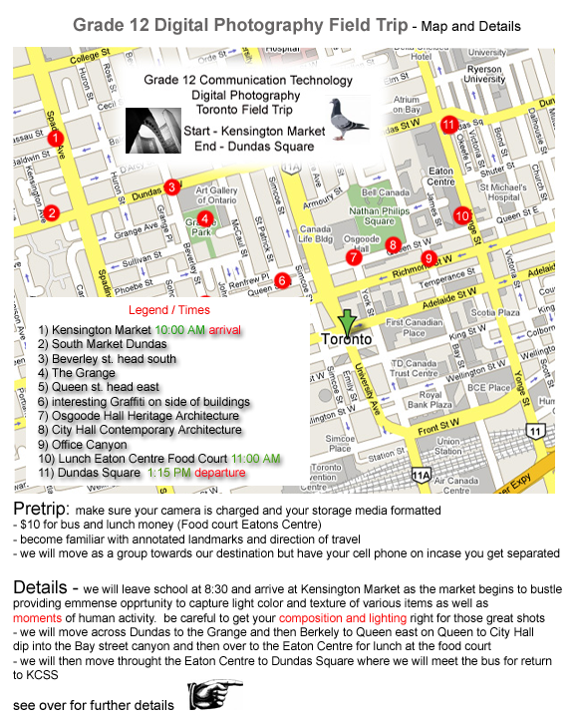

Toronto Digital Photography
Field Trip
On this trip we will walk as a group from Kensington Market to Dundas Square with Lunch at Eaton's Centre Food Court.
$ 10 bus fee / $$ for lunch at food court
- get your camera/batteries/storage media ready the night before
Bus will leave South West corner of Yonge Dundas at 1:15pm
If you get separated from the group call me or some one else's cell phone until you get back in the group.

We will regroup at each of the main numbered points of interest
- You will take around 160 pix
- You will create a labeled contact sheet and print it out
- You will create a FLASH slideshow from a template in FLASH MX using 1 processed image from each category
- Your slide show will be posted to the Internet with a link from your website
- You will produce a Panorama picture from a linear sequence of many photos taken at an appropriate location such as the Grange, OCAD, City Hall, Dundas Square etc.
Categories
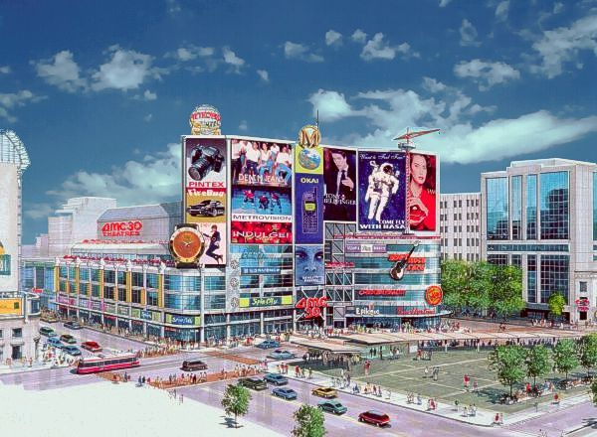
People
Moments
Food
Weird
Bird/Animal
Old Buildings
Modern Buildings
Tree
other things of interest/car/homeless etc.
PANORAMA at City Hall
teacher's phone 416 402 8150
other cell phone_________________

